|  |
| --- |
| **REQUIREMENT SPECIFICATIONS** |
| V 1.2 |
|  |
|  |
|  |
| **Pookas ETventure** |
|  |
|  |

# Revision History

|  |  |  |  |
| --- | --- | --- | --- |
| Revision Number | Date | Primary Author(s) | Comments |
| 1.0 | 4 Sep 2009 | Ivan Loh, Sarah Lam, Gillian Ng Lui Quan Fu, Goh Li-Xian | First Version |
| 1.1 | 1 Oct 2009 | Ivan Loh, Goh Li-Xian | Refined Req Specs |
| 1.2 | 10 Oct 2009 | Goh Li-Xian | Refined Use case |

# 1 Requirement Specifications

Our Active World project involves Virtual Classroom and Edventure, making it a virtual world where student will be able to attend lectures and retrieve various documents from Edventure. These allow student the flexibility of attending lectures at any time of the day.

### Lecturer Bots

We intend to enhance the existing Active World project by incorporating Virtual Lectures with virtual lecturer bots. A student Avatar walks in one of the Lecture theatre (LT), and he can talk to the professor. He will also be able to select the lesson he wants to attend from the projection screen in the front of the LT. After some interactive selection, the selected lesson will be lectured to the student. Base on the selected lecture, the corresponding Powerpoint slides will be retrieved directly NTU’s Edventure Portal.

The lecturer bot will retrieve announcements from Edventure. Latest announcement is broadcasted to user upon their login. Older announcements have to be viewed by talking to the lecturer bot. Users talk to the lecturer bot on administrative topics regarding the course. The bot will be able to respond with answers based on AIML implementation. During lectures, we will allow students to ask questions and the virtual professor will respond based on his set of knowledge we input. This allows students to get more insight and knowledge from the virtual professors that are not in the slides.

### Game Quiz

We are also adding in a game quiz section to avatars to play a multi-answer quiz game. The quiz questions will be retrieved from Edventure based on the module selected by the avatar. The user starts the game quiz by talking to the Quiz Bot. The Quiz Bot starts the round after waiting for a configurable wait time is up. The questions will be flashed on the screen and he will selects his answers (A,B,C,D) by running to one of the four square boxes that correspond to the answers. After a configurable round time is up, the Quiz Bot ends the round and tabulate the results and saved into our system. Players can choose to leave the game between rounds, but no additional players are allowed to join. The new round will start the process over again.

### Broadcast Message

Another feature we will implement is to allow student avatars to broadcast messages to other avatars who are registered for the same course code based on their registration info in edventure. This allows students to share information with fellow course mates. Lecturers will also be able to broadcast announcements to students in his course based on the same implementation. The announcement will also be posted to Edventure whenever the lecturer broadcast in the Active World.

### Teleporting Around

As the world is huge, it will take an avatar quite a while to navigate around. We will introduce teleporting points to allow avatars to reach certain attractions instantly. The teleport points will be placed at strategic locations to maximize its effectiveness.

Based on all our requirements, we have developed the necessary Use Case and Activity Diagrams.

## 1.1 Use Case

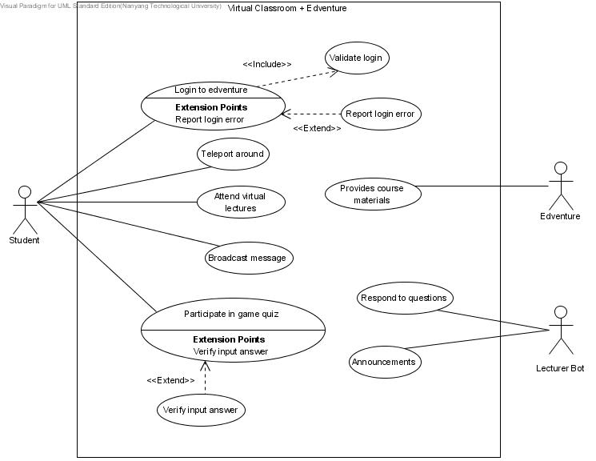

Fig.1 Virtual Classroom & Edventure Use Case Diagram